**Project Instructions**

**Instructions**

Using Google Trends, you've been asked to generate a report on changes in browser popularity since 2004. There are five browsers you'll be looking into: Firefox, Safari, Chrome, Internet Explorer, and Opera. For the report, you need to calculate three key metrics:

1. Find the six month **rolling average** (a.k.a. simple moving average) for each date and browser in the dataset. Save your answer as pandas DataFrame called rolling\_six with the column Month as the index. Null values are acceptable for dates where a rolling six month average can't be generated.
2. Similar to above, create a DataFrame called pct\_change\_quarterly with the **percentage change from the previous quarter** for each date and browser. The values should be in percentage format, so 5 instead of 0.05. Since Chrome launched in late 2008, only include dates during or after 2009.
3. From the earlier questions, you can see that even though Chrome eventually overtook Firefox, Chrome's growth has had its fair share of ups and downs. You will illustrate this by comparing Chrome's **annual Google Trends performance in 2009, 2012, 2015, and 2018** in a DataFrame called chrome\_trends. It should hold the search interest for Chrome with four columns for each year and twelve rows for each month of the year.

**Plotting your answers**

To make the report, you can visualize your DataFrames using **[pandas.DataFrame.plot](https://pandas.pydata.org/pandas-docs/stable/reference/api/pandas.DataFrame.plot.html" \t "_blank)**. This is not tested so customize your plots as you wish! Here are examples:

* rolling\_six.plot(title="6 Month Rolling Avg")
* pct\_change\_quarterly.plot(subplots=True, figsize=(12,8))
* chrome\_trends.plot(title="Chrome Search Performance in 2009, 2012, 2015 & 2018")

I figured I might not be able to finish the project on data camp so … I dropped the question here I’ll do it locally and push to my github in doing so I’ll be perfecting git as well as getting hands on on real life project.

## Welcome to the Browser Wars (1995 - )

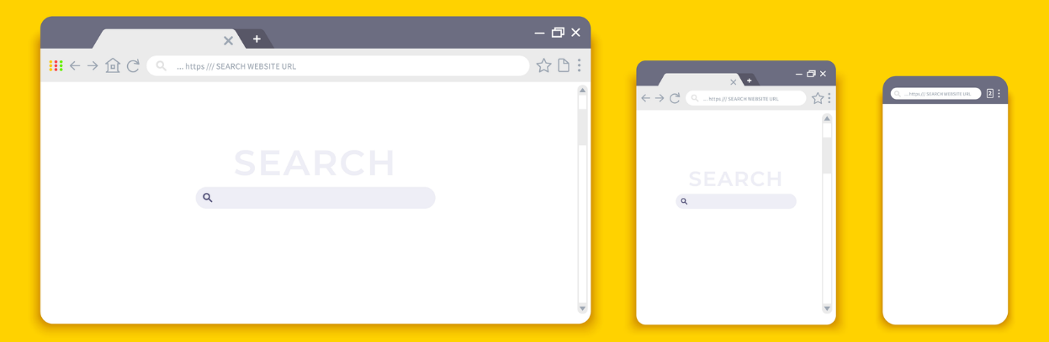

In the mid 1990s, the First Browser War began with Netscape Navigator and Microsoft Internet Explorer fighting for dominance. By 2001, Internet Explorer was the clear winner, but it was not long before the Second Browser Wars began (2004-2017). This coincided with the rise of smartphones, which emphasized the need and competitiveness for more mobile-friendly versions of browsers. [[1]](https://en.wikipedia.org/wiki/Browser_wars)

In this notebook, we'll analyze the worldwide popularity of browsers over time using Google Trends. Although this won't give us direct market share figures, we can use Google Trends to get a sense of interest of a given browser over time and how that interest compares to other browsers. In particular, we will be looking at five major players over the past two decades: Mozilla Firefox (2002-), Apple's Safari (2002-), Google Chrome (2008-), Microsoft Internet Explorer (1995-2020), and Opera (1995-).

The dataset you will use was downloaded as a CSV from this [Google Trends query](https://trends.google.com/trends/explore?date=all&q=%2Fm%2F01dyhm,%2Fm%2F0168s_,%2Fm%2F04j7cyf,%2Fm%2F03xw0,%2Fm%2F01z7gs) in mid-October of 2020. Here are the details:

**datasets/worldwide\_browser\_trends.csv**

This is a time series indexed by month with the search interest for each browser.

* **Month:** each month from 2004-01 to 2020-10
* **Firefox:** search interest for Firefox
* **Safari:** search interest for Safari
* **Google Chrome:** search interest for Chrome
* **Internet Explorer:** search interest for Internet Explorer
* **Opera:** search interest for Opera

Google defines the values of search interest as:

Numbers represent search interest relative to the highest point on the chart for the given region and time. A value of 100 is the peak popularity for the term. A value of 50 means that the term is half as popular. A score of 0 means there was not enough data for this term.

Best of luck and may the best browser win!